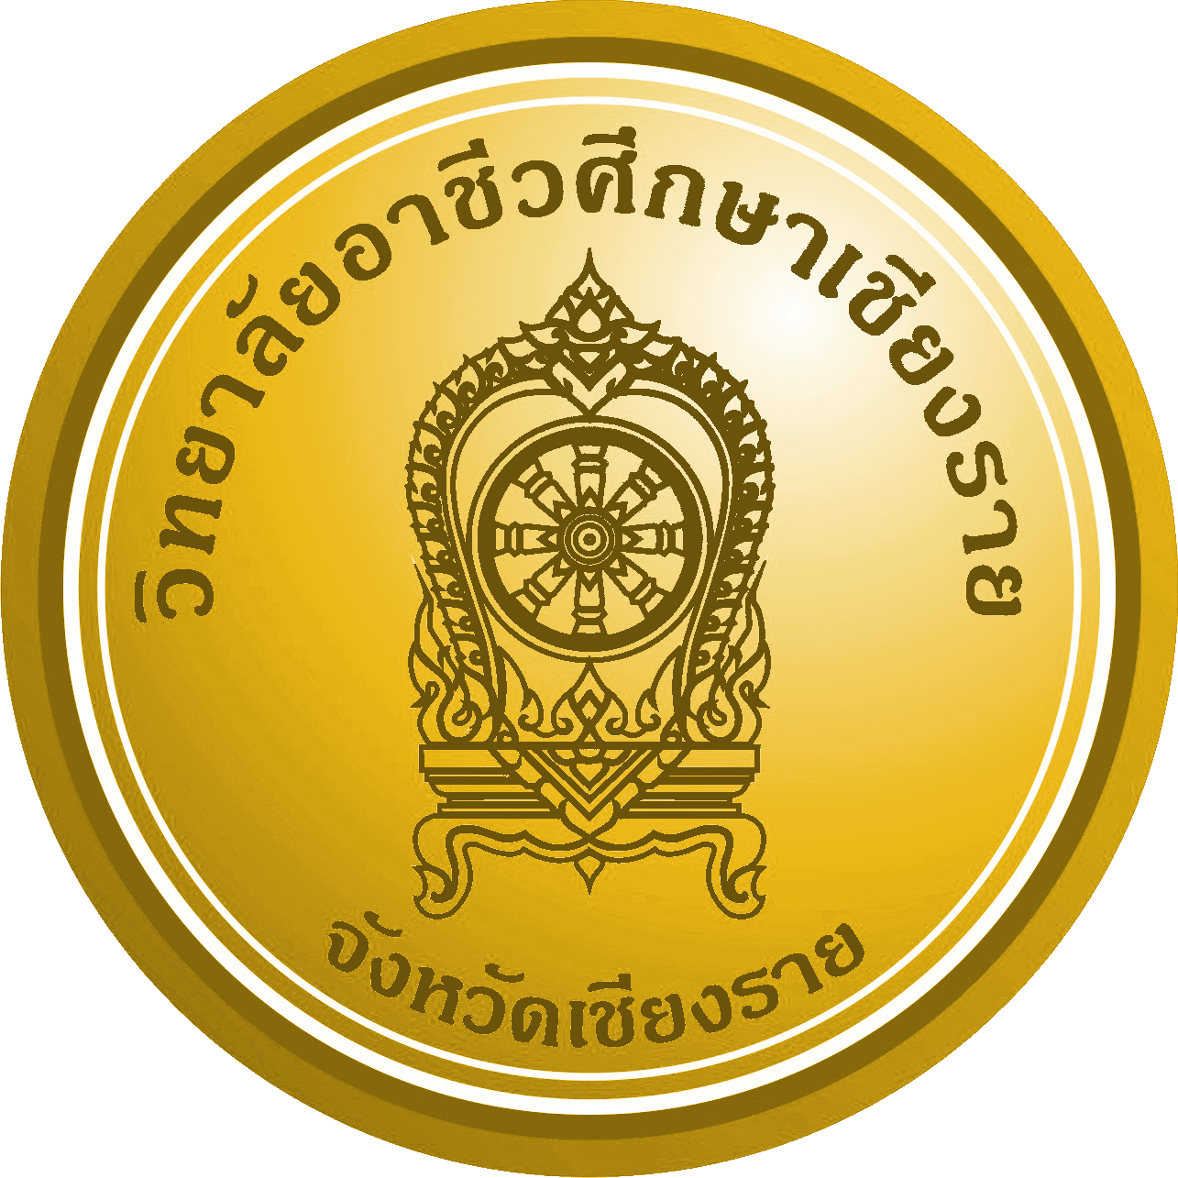
Course Syllabus
Code : Course : No. of : Credit Hours
Course status : Pre-requisite :
Semester : Class Meeting :
Instructor : Office :
Position : Qualification :
Phone : E-Mail :
Text Book :
Reference :
Course Objectives
1.
2.
3.
Course Standards
1.
2.
Course Description

Competency
Knowledge
1.
2.
3.
Skills
1.
2.
Moral
1.
2.
KPI : Key Performance Indicator
1.
2.
3.
Mark Allocatic Criteria Requires .... parts (Total 100%)
1.
2.
3.
4.
Instructional Strategies

Work Assignments

Assessment

Description Of Course Syllabus : Subject ....................................... 18 weeks ... hours
No. | Topic | Activities and Teaching procedure | Teaching Media | Evaluation | Competency
1
2
3
4
5
6
7
8
9
10
11
12
13
14
15
16
17
18

Remarks

